

Seasonal Fruits

Aenean commodo ligula eget dolor
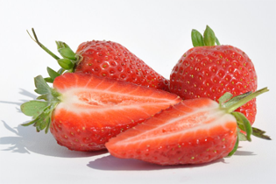
Far far away, behind the word mountains, far from the countries Vokalia and Consonantia, there live the blind texts. Separated they live in Bookmarksgrove right at the coast of the Semantics, a large language ocean. A small river named Duden flows by their place and supplies it with the necessary regelialia. It is a paradisematic country, in which roasted parts of sentences fly into your mouth. Even the all-powerful Pointing has no control about the blind texts it is an almost unorthographic life One day however a small line of blind text by the name of Lorem Ipsum decided to leave for the far World of Grammar. The Big Oxmox advised her not to do so, because there were thousands of bad Commas, wild Question Marks and devious Semikoli, but the Little Blind Text didn’t listen. She packed her seven versalia, put her initial into the belt and made herself on the way. When she reached the first hills of the Italic Mountains, she had a last view back on.

Donec quam felis

Nulla consequat massa quis enim.
Far far away, behind the word mountains, far from the countries Vokalia and Consonantia, there live the blind texts. Separated they live in Bookmarksgrove right at the coast of the Semantics, a large language ocean. A small river named Duden flows by their place and supplies it with the necessary regelialia. It is a paradisematic country, in which roasted parts of sentences fly into your mouth. Even the all-powerful Pointing has no control about the blind texts it is an almost unorthographic life One day however a small line of blind text by the name of Lorem Ipsum decided to leave for the far World of Grammar. The Big Oxmox

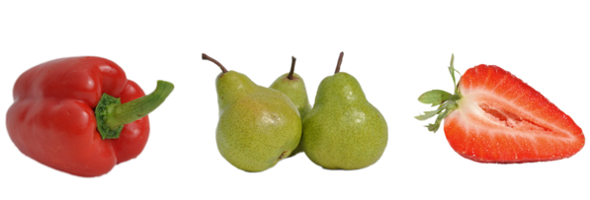

Pellentesque posuere. | Praesent turpis. | Aenean posuere.
9,98 Euro/kg | 2,99 Euro/kg | 3,55 Euro/kg
Italien | Chile | Deutschland

Phasellus ullamcorper ipsum rutrum nunc.

Far far away, behind the word mountains, far from the countries Vokalia and Consonantia, there live the blind texts. | Far far away, behind the word mountains, far from the countries Vokalia and Consonantia, there live the blind texts. | Far far away, behind the word mountains, far from the countries Vokalia and Consonantia, there live the blind texts.
 |  | 
  I'm Dummy text | I'm Dummy text

Nam eget dui
Nam eget dui. Etiam rhoncus. Maecenas tempus, tellus eget condimentum rhoncus, sem quam semper libero, sit amet adipiscing sem neque sed ipsum.

Etiam rhoncus
Etiam rhoncus. Maecenas tempus, tellus eget condimentum rhoncus, sem quam semper libero, sit amet adipiscing sem neque sed ipsum. Nam quam nunc, blandit vel, luctus pulvinar, hendrerit id, lorem.

Aenean massa
Aenean imperdiet. Etiam ultricies nisi vel augue. Curabitur ullamcorper ultricies nisi. Nam eget dui. Etiam rhoncus. Maecenas tempus, tellus eget condimentum rhoncus, sem quam semper libero, sit amet adipiscing sem neque sed ipsum. Nam quam nunc, blandit vel, luctus pulvinar, hendrerit id, lorem. Maecenas nec odio et ante tincidunt tempus. Donec vitae sapien ut libero venenatis faucibus.

Cras dapibus
Cras dapibus. Vivamus elementum semper nisi.

Phasellus ullamcorper ipsum rutrum nunc.

Far far away, behind the word mountains, far from the countries Vokalia and Consonantia, there live the blind texts. Separated they live in Bookmarksgrove right at the coast of the Semantics, a large language ocean.

A small river named Duden flows by their place and supplies it with the necessary regelialia. It is a paradisematic country, in which roasted parts of sentences fly into your mouth.
Even the all-powerful Pointing has no control about the blind texts it is an almost unorthographic life One day however a small line of blind text by the name of Lorem Ipsum decided to leave for the far World of Grammar.

